**Exercise 1: Configuring a Basic Spring Application**

**Code:**

**Basic Application.java**

package com.example.demo;

import com.example.demo.service.BookService;

import org.springframework.context.ApplicationContext;

import org.springframework.context.support.ClassPathXmlApplicationContext;

public class BasicApplication {

public static void main(String[] args) {

ApplicationContext context = new ClassPathXmlApplicationContext("applicationContext.xml");

// Get BookService bean

BookService bookService = (BookService) context.getBean("bookService");

// Call method

bookService.listBooks();

}

}

**Application.Context.xml**

<?xml version="1.0" encoding="UTF-8"?>

<beans xmlns="http://www.springframework.org/schema/beans"

xmlns:xsi="http://www.w3.org/2001/XMLSchema-instance"

xsi:schemaLocation="

http://www.springframework.org/schema/beans

http://www.springframework.org/schema/beans/spring-beans.xsd">

<!-- Define BookRepository bean -->

<bean id="bookRepository" class="com.example.demo.repository.BookRepository" />

<!-- Define BookService bean and inject BookRepository -->

<bean id="bookService" class="com.example.demo.service.BookService">

<property name="bookRepository" ref="bookRepository" />

</bean>

</beans>

**Pom.xml**

<?xml version="1.0" encoding="UTF-8"?>

<project xmlns="http://maven.apache.org/POM/4.0.0" xmlns:xsi="http://www.w3.org/2001/XMLSchema-instance"

xsi:schemaLocation="http://maven.apache.org/POM/4.0.0 https://maven.apache.org/xsd/maven-4.0.0.xsd">

<modelVersion>4.0.0</modelVersion>

<parent>

<groupId>org.springframework.boot</groupId>

<artifactId>spring-boot-starter-parent</artifactId>

<version>3.5.3</version>

<relativePath/> <!-- lookup parent from repository -->

</parent>

<groupId>com.example</groupId>

<artifactId>demo</artifactId>

<version>0.0.1-SNAPSHOT</version>

<name>Basic</name>

<description>Demo project for Spring Boot</description>

<url/>

<licenses>

<license/>

</licenses>

<developers>

<developer/>

</developers>

<scm>

<connection/>

<developerConnection/>

<tag/>

<url/>

</scm>

<properties>

<java.version>24</java.version>

</properties>

<dependencies>

<dependency>

<groupId>org.springframework</groupId>

<artifactId>spring-context</artifactId>

<version>5.3.34</version> <!-- or latest non-Boot version -->

</dependency>

<dependency>

<groupId>org.springframework.boot</groupId>

<artifactId>spring-boot-starter</artifactId>

</dependency>

<dependency>

<groupId>org.springframework.boot</groupId>

<artifactId>spring-boot-starter-test</artifactId>

<scope>test</scope>

</dependency>

</dependencies>

<build>

<plugins>

<plugin>

<groupId>org.springframework.boot</groupId>

<artifactId>spring-boot-maven-plugin</artifactId>

</plugin>

</plugins>

</build>

</project>

**Ouput**

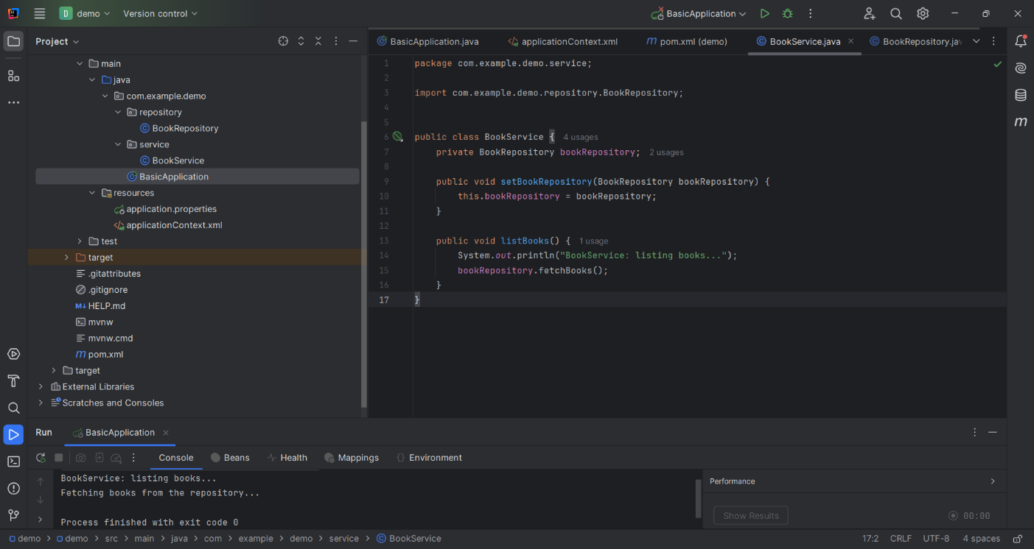

**Excercise 2:Implementing Dependency Injection**

**Code:**

**Basic Application.java**

package com.example.demo;

import com.example.demo.service.BookService;

import org.springframework.context.ApplicationContext;

import org.springframework.context.support.ClassPathXmlApplicationContext;

public class BasicApplication {

public static void main(String[] args) {

ApplicationContext context = new ClassPathXmlApplicationContext("applicationContext.xml");

BookService bookService = (BookService) context.getBean("bookService")

bookService.listBooks();

}

}

**ApplicationContext.xml**

<?xml version="1.0" encoding="UTF-8"?>

<beans xmlns="http://www.springframework.org/schema/beans"

xmlns:xsi="http://www.w3.org/2001/XMLSchema-instance"

xsi:schemaLocation="

http://www.springframework.org/schema/beans

http://www.springframework.org/schema/beans/spring-beans.xsd">

<!-- BookRepository Bean -->

<bean id="bookRepository" class="com.example.demo.repository.BookRepository"/>

<!-- BookService Bean with DI -->

<bean id="bookService" class="com.example.demo.service.BookService">

<property name="bookRepository" ref="bookRepository"/>

</bean>

</beans>

**Pom.xml**

<?xml version="1.0" encoding="UTF-8"?>

<project xmlns="http://maven.apache.org/POM/4.0.0" xmlns:xsi="http://www.w3.org/2001/XMLSchema-instance"

xsi:schemaLocation="http://maven.apache.org/POM/4.0.0 https://maven.apache.org/xsd/maven-4.0.0.xsd">

<modelVersion>4.0.0</modelVersion>

<parent>

<groupId>org.springframework.boot</groupId>

<artifactId>spring-boot-starter-parent</artifactId>

<version>3.5.3</version>

<relativePath/> <!-- lookup parent from repository -->

</parent>

<groupId>com.example</groupId>

<artifactId>demo</artifactId>

<version>0.0.1-SNAPSHOT</version>

<name>Basic</name>

<description>Demo project for Spring Boot</description>

<url/>

<licenses>

<license/>

</licenses>

<developers>

<developer/>

</developers>

<scm>

<connection/>

<developerConnection/>

<tag/>

<url/>

</scm>

<properties>

<java.version>24</java.version>

</properties>

<dependencies>

<dependency>

<groupId>org.springframework</groupId>

<artifactId>spring-context</artifactId>

<version>5.3.34</version> <!-- or latest non-Boot version -->

</dependency>

<dependency>

<groupId>org.springframework.boot</groupId>

<artifactId>spring-boot-starter</artifactId>

</dependency>

<dependency>

<groupId>org.springframework.boot</groupId>

<artifactId>spring-boot-starter-test</artifactId>

<scope>test</scope>

</dependency>

</dependencies>

<build>

<plugins>

<plugin>

<groupId>org.springframework.boot</groupId>

<artifactId>spring-boot-maven-plugin</artifactId>

</plugin>

</plugins>

</build>

</project>

**Output**

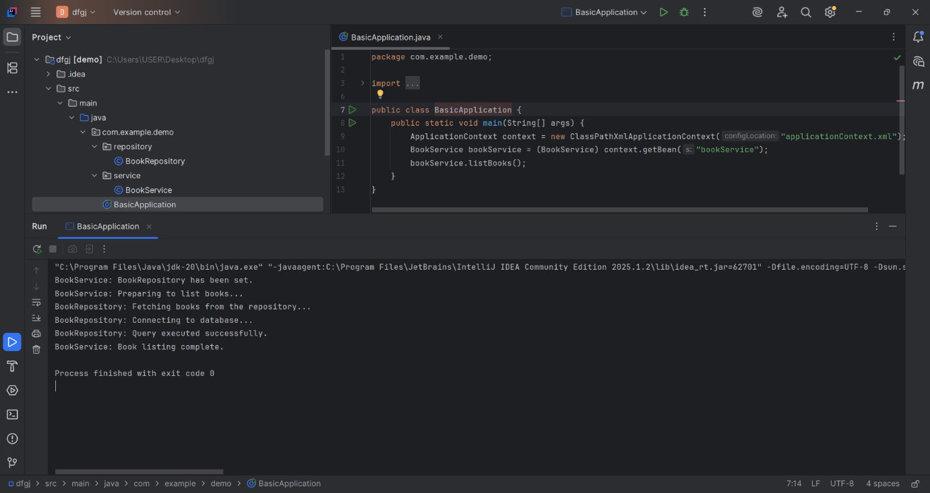

**Excercise 4:Creating and Configuring the Maven Project**

**Code:**

**Pom.xml**

<?xml version="1.0" encoding="UTF-8"?>

<project xmlns="http://maven.apache.org/POM/4.0.0" xmlns:xsi="http://www.w3.org/2001/XMLSchema-instance"

xsi:schemaLocation="http://maven.apache.org/POM/4.0.0 https://maven.apache.org/xsd/maven-4.0.0.xsd">

<modelVersion>4.0.0</modelVersion>

<parent>

<groupId>org.springframework.boot</groupId>

<artifactId>spring-boot-starter-parent</artifactId>

<version>3.5.3</version>

<relativePath/> <!-- lookup parent from repository -->

</parent>

<groupId>com.example</groupId>

<artifactId>config</artifactId>

<version>0.0.1-SNAPSHOT</version>

<name>config</name>

<description>Demo project for Spring Boot</description>

<url/>

<licenses>

<license/>

</licenses>

<developers>

<developer/>

</developers>

<scm>

<connection/>

<developerConnection/>

<tag/>

<url/>

</scm>

<properties>

<java.version>24</java.version>

</properties>

<dependencies>

<dependency>

<groupId>org.springframework.boot</groupId>

<artifactId>spring-boot-starter</artifactId>

</dependency>

<dependency>

<groupId>org.springframework.boot</groupId>

<artifactId>spring-boot-starter-test</artifactId>

<scope>test</scope>

</dependency>

<!-- Spring Core/Context -->

<dependency>

<groupId>org.springframework</groupId>

<artifactId>spring-context</artifactId>

<version>6.2.7</version>

</dependency>

<!-- Spring AOP -->

<dependency>

<groupId>org.springframework</groupId>

<artifactId>spring-aop</artifactId>

<version>5.3.34</version>

</dependency>

<!-- Spring WebMVC -->

<dependency>

<groupId>org.springframework</groupId>

<artifactId>spring-webmvc</artifactId>

<version>6.1.14</version>

</dependency>

<!-- Servlet API (for Spring MVC) -->

<dependency>

<groupId>javax.servlet</groupId>

<artifactId>javax.servlet-api</artifactId>

<version>4.0.1</version>

<scope>provided</scope>

</dependency>

</dependencies>

<build>

<plugins>

<plugin>

<groupId>org.springframework.boot</groupId>

<artifactId>spring-boot-maven-plugin</artifactId>

</plugin>

<plugin>

<groupId>org.apache.maven.plugins</groupId>

<artifactId>maven-compiler-plugin</artifactId>

<version>3.10.1</version>

<configuration>

<source>1.8</source>

<target>1.8</target>

</configuration>

</plugin>

</plugins>

</build>

</project>

**Output 1:**

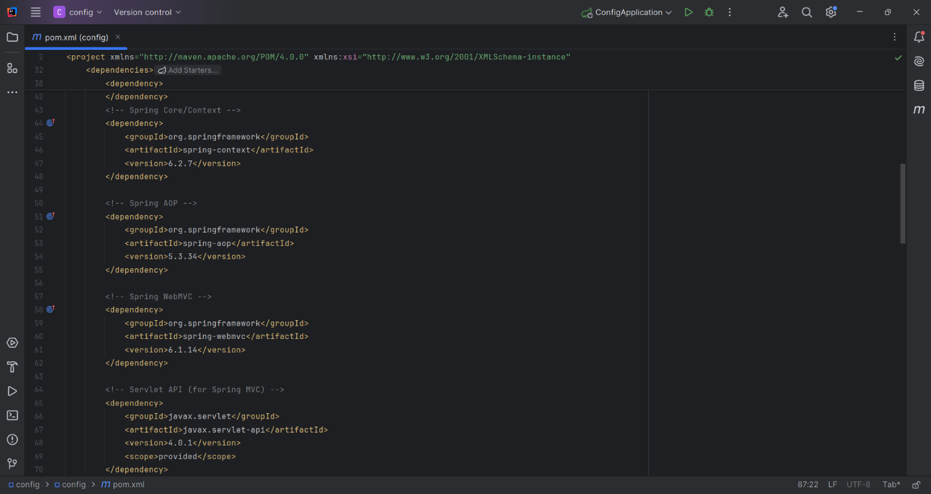

**Output2:**

